**Best Fashion Trends in 2016 for Stylish Men**

2016 has brought some new and interesting fashion ideas. From apparel, accessories, jewelry and décor, most people have confirmed that indeed 2016 is the fashionable year. If you are the man who has to keep up with new fashion trends, then you have found the right place. We have some ideas that will point you in the right direction if you are looking for fashion this year. All your fashion needs will be sorted out. You will not need to visit every website, store or read every magazine to know about the trends. Use the ideas below to find out where to get the best fashion trends for 2016.

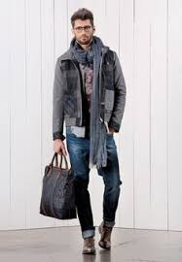

**The Pajama Touch**

For 2016, the pajama has risen to a whole new level. Designers have added new ideas to the traditional pajama. Pajama suits are especially, the rocking trend for men in 2016. The soft silk will undoubtedly be smooth on your skin, and the excellent designs will make you stand out.

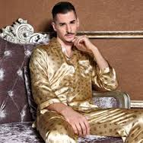 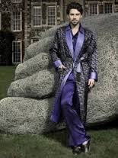

**The Neckerchief Experience**

Ditch thick scarves and go for the elegant neckerchiefs that make you stand out among the rest. Go for neckerchiefs that have bold prints and excellent patterns. Cover your neck and feel good about it.

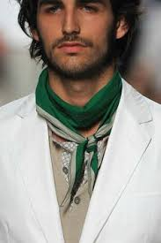 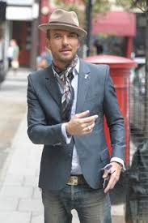

**Knitted Polo Shirt**

Tired with your normal t-shirts? Perhaps it is time you opted for the knitted polo shirts that promise to revolutionize your wardrobe. You can pair this with other outfits like suits and the look is just amazing. Invest in knitted polo shirts that have solid colors so that you can pair them with several outfits in your wardrobe.

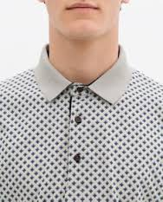 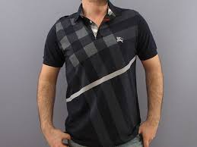

**Dazzle with the Duffle Coat**

Coats have a new feel, thanks to the duffle coat. Go for this great piece of apparel that has been the talk of town among men. The fashionable duffle coat has several designs like a hood and extended sleeves. Be the first to rock this elegant coat.

